HOSPITAL ER ANALYSIS SQL QUERIES

- EDA
A . Number of Patients:
SELECT count(DISTINCT patient_id)
FROM hospital_er_data_copy;
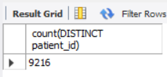
B . Average Wait Time:
SELECT AVG(patient_wait_time)
FROM hospital_er_data_copy;
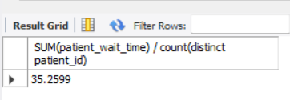
C. Median Value of patient wait time:
WITH cte_median_waittime AS
( SELECT *,
ROW_NUMBER() over(order by patient_wait_time) as index_
FROM hospital_er_data_dup) ,
total_count AS
(SELECT COUNT(*) AS cnt
FROM hospital_er_data_dup) ,
Cte_median_waittime2 AS
( SELECT c. patient_wait_time, c.index_
FROM cte_median_waittime c
CROSS JOIN total_count d
WHERE d.cnt % 2 = 0 AND c.index_ IN (d.cnt/2, d.cnt/2 + 1) OR
d.cnt % 2 = 1 AND c.index_ IN (FLOOR(d.cnt/2) +1)
)
SELECT AVG(patient_wait_time) AS median_waittime
FROM Cte_median_waittime2;
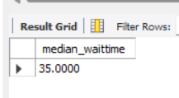
D. Average Patient Satisfaction Score & Most given satisfaction score:
SELECT ROUND(AVG(satisfaction_score), 2) AS avg_sat_score
FROM hospital_er_data_copy;
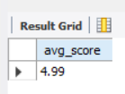
Patient Satisfaction Score (MODE):
WITH cte_satisfaction_score_mode AS
(SELECT satisfaction_score, COUNT(satisfaction_score) AS cnt
FROM hospital_er_data_dup
WHERE satisfaction_score IS NOT NULL
GROUP BY satisfaction_score
ORDER BY cnt desc)
SELECT satisfaction_score
FROM cte_satisfaction_score_mode
LIMIT 1;
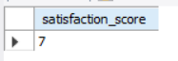

E. Number of Patients Referred to Department after ER:
SELECT COUNT(Department_referral)
FROM hospital_er_data_copy
WHERE Department_referral != 'NONE';
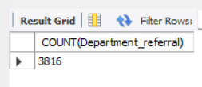

F. Measure the total number of patients visiting the ER as per month & year.
- As Per month :
SELECT monthname,counts
FROM(SELECT MONTH(admission_date) as month_no, monthname, COUNT(patient_id) AS counts
FROM hospital_er_data_dup
GROUP BY month_no,monthname
ORDER BY month_no) AS month_vs_patientcounts_;
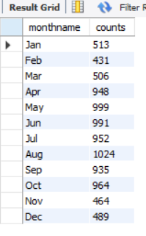

- As Per year:
SELECT year, COUNT(patient_id) AS counts
FROM hospital_er_data_dup
GROUP BY year;
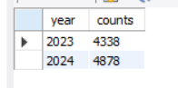

- As Per year: & months patients counts :
SELECT year, monthname, counts
FROM(SELECT year, MONTH(admission_date) as month_no, monthname, COUNT(patient_id) AS counts
FROM hospital_er_data_dup
GROUP BY year, month_no, monthname
ORDER BY year, month_no) AS patient_nos;
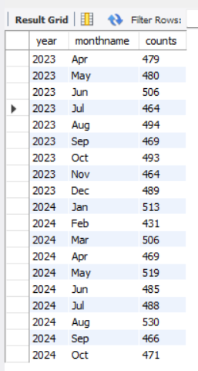
- As Per Season:

SELECT
CASE
WHEN monthname IN ('Jan','Feb') THEN 'Winter'
WHEN monthname IN ('Mar','Apr','May') THEN 'Summer'
WHEN monthname IN ('Jun','Jul','Aug','Sep') THEN 'Monsoon'
WHEN monthname IN ('Oct','Nov','Dec') THEN 'Autumn'
END AS season,
COUNT(*) AS patient_counts
FROM hospital_er_data_dup
GROUP BY season;

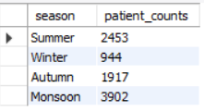
G. Calculate the Average Wait Time as per the month(season):
Let’s learns which month or season has patients has waited for more.
WITH cte_month_avg_waittime AS
(SELECT monthname, MONTH(admission_date) as month_no, COUNT(patient_wait_time) AS counts, CAST(AVG(patient_wait_time) AS decimal(7,2)) as Average_wait_time
FROM hospital_er_data_dup
GROUP BY monthname, month(admission_date)
ORDER BY month_no)
SELECT monthname,Counts,Average_wait_time
FROM cte_month_avg_waittime;
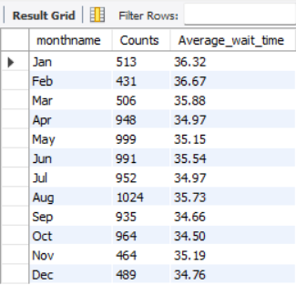

H. Calculate the Average satisfaction score as per the month(season):

WITH cte_month_avg_satisfactionscore AS
(SELECT monthname, MONTH(admission_date) as month_no, COUNT(satisfaction_score) AS counts, CAST(AVG(satisfaction_score) AS decimal(7,2)) as AVERAGE
FROM hospital_er_data_dup
GROUP BY monthname,month(admission_date)
ORDER BY month_no)
SELECT monthname,Counts,AVERAGE
FROM cte_month_avg_satisfactionscore;
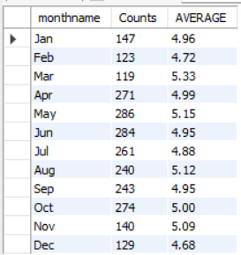
- Count the patients referred to specific departments from the ER as per month( season).

Eg: lets checks for the summer month department referral counts

WITH cte_hospital AS
(SELECT Department_referral, monthname, month(admission_date) as month_no,
CASE
WHEN monthname IN ('Jan','Feb') THEN 'Winter'
WHEN monthname IN ('Mar','Apr','May') THEN 'Summer'
WHEN monthname IN ('Jun','Jul','Aug','Sep') THEN 'Monsoon'
WHEN monthname IN ('Oct','Nov','Dec') THEN 'Autumn'
END AS season
FROM hospital_er_data_dup),
cte_hospital2 AS
(SELECT department_referral,season,COUNT(*) as referral_count
FROM cte_hospital
GROUP BY department_referral, season
ORDER BY department_referral)
SELECT Department_referral,referral_count
FROM cte_hospital2
WHERE season = 'Summer'
ORDER BY referral_count DESC;

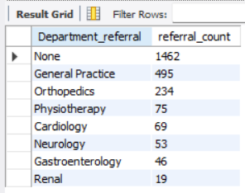

- Top 2 Departmental Referrals by Month and their patient counts.
WITH cte_hospital AS
(SELECT Department_referral, monthname, month(admission_date) as month_no
FROM hospital_er_data_dup
ORDER BY month_no),
cte_hospital2 AS
(SELECT monthname, month_no, department_referral, COUNT(*) as referral_count
FROM cte_hospital
GROUP BY monthname, month_no, department_referral
ORDER BY month_no ASC, referral_count DESC)
SELECT monthname, department_referral, referral_count
FROM cte_hospital2;

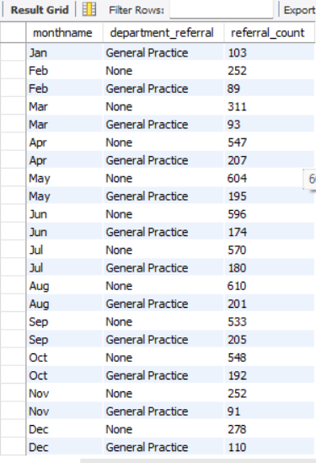

- How does the wait time vary by patient gender or race?

- For gender query:
SELECT gender, ROUND(AVG(patient_wait_time))
FROM hospital_er_data_dup
GROUP BY gender;
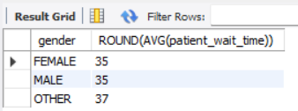

- For race query:

SELECT patient_race, CAST(AVG(patient_wait_time)AS DECIMAL(7,2) ) AVG
FROM hospital_er_data_dup
GROUP BY patient_race;
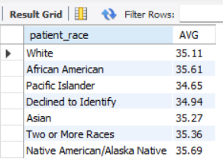
- What is the average wait time per department referral?

SELECT department_referral,
AVG(patient_wait_time) AS Average
FROM hospital_er_data_dup
GROUP BY Department_referral;

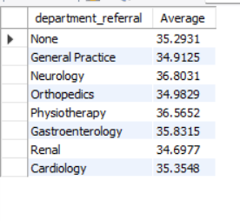
- How many patients were admitted vs not admitted each day
SELECT patient_admission_flag, days, counts
FROM (
SELECT patient_admission_flag, DATE_FORMAT(admission_date,'%W') AS days,WEEKDAY(admission_date) AS week_no, COUNT(*) AS counts
FROM hospital_er_data_dup
GROUP BY patient_admission_flag, days,week_no
ORDER BY Patient_admission_flag ASC, week_no ASC ) AS table1;
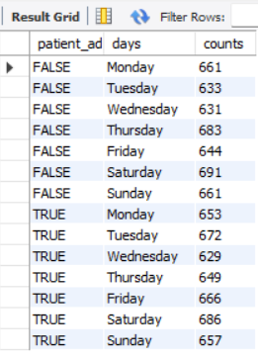
- What percentage of patients are admitted after visiting the ER?

SELECT Patient_admission_flag,
COUNT(*)/(SELECT COUNT(*) FROM hospital_er_data_dup) as percentage
FROM hospital_er_data_dup
GROUP BY Patient_admission_flag;
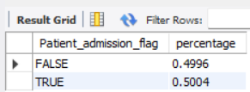

- What is the admission rate by patient age group?
Admission rate for age group =
Counts for admitted patient by age group /
Counts for Total (both admitted and non- adm) patient by age group
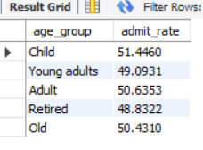

SELECT age_group, admit_rate
FROM (
SELECT
CASE
WHEN age < 18 THEN 'Child'
WHEN age BETWEEN 18 AND 32 THEN 'Young adults'
WHEN age BETWEEN 33 AND 55 THEN 'Adult'
When age BETWEEN 56 and 75 THEN 'Retired'
WHEN age > 75 THEN 'Old'
END AS age_group,
COUNT(*) AS age_counts,
COUNT(CASE WHEN Patient_admission_flag = 'True' THEN 1 END) AS admitted_patients,
(COUNT(CASE WHEN Patient_admission_flag = 'True' THEN 1 END) / COUNT(*)) * 100 as admit_rate
FROM hospital_er_data_dup
GROUP BY age_group ) AS table1
HAVING age_group IS NOT NULL
ORDER BY
CASE
WHEN age_group = 'Child' THEN 1
WHEN age_group = 'Young adults' THEN 2
WHEN age_group = 'Adult' THEN 3
WHEN age_group = 'Retired' THEN 4
WHEN age_group = 'Old' THEN 5
END;
- What is the average satisfaction score per day
AS per date:
SELECT DATE_FORMAT(admission_date,'%a') AS month_day,
AVG(satisfaction_score) AS average, MAX(satisfaction_score) AS MAX, MIN(satisfaction_score) AS MIN
FROM hospital_er_data_dup
GROUP BY month_day;
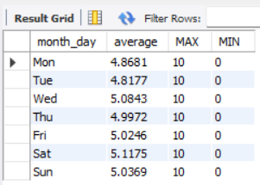 , 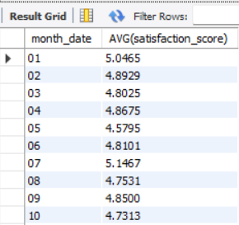
AS per date:
SELECT DATE_FORMAT(admission_date,'%d') AS month_date, AVG(satisfaction_score)
FROM hospital_er_data_dup
GROUP BY month_date
ORDER BY month_date;

- How does patient satisfaction vary by gender, race, admission flag and Age group?
GENDER:
SELECT gender, COUNT(*) AS count,
AVG(satisfaction_score) AS average_sat_score,
MAX(satisfaction_score) AS Max_sat_score
FROM hospital_er_data_dup
GROUP BY gender;
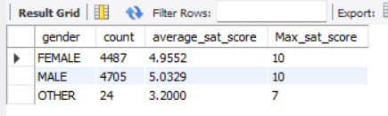
RACE:
SELECT patient_race, COUNT(*) AS count,
AVG(satisfaction_score) AS average_sat_score,
MAX(satisfaction_score) AS Max_sat_score
FROM hospital_er_data_dup
GROUP BY patient_race;
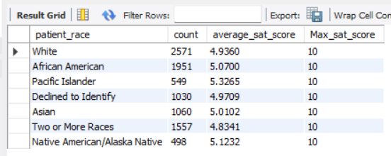
Admission flag :
SELECT Patient_admission_flag, COUNT(*) AS count,
AVG(satisfaction_score) AS average_sat_score,
MAX(satisfaction_score) AS Max_sat_score
FROM hospital_er_data_dup
GROUP BY Patient_admission_flag;
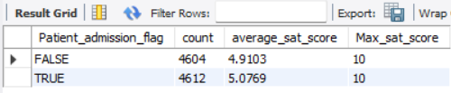

Age group :

SELECT age_group, COUNT(*) AS count,
CAST(AVG(satisfaction_score) AS DECIMAL (10,2)) AS average_sat_score,
MAX(satisfaction_score) AS Max_sat_score
FROM (
SELECT
CASE
WHEN age < 18 THEN 'Child'
WHEN age BETWEEN 18 AND 32 THEN 'Young adults'
WHEN age BETWEEN 33 AND 55 THEN 'Adult'
When age BETWEEN 56 and 75 THEN 'Retired'
WHEN age > 75 THEN 'Old'
END AS age_group, satisfaction_score
FROM hospital_er_data_dup
) AS table1
GROUP BY age_group
ORDER BY
CASE
WHEN age_group = 'Child' THEN 1
WHEN age_group = 'Young adults' THEN 2
WHEN age_group = 'Adult' THEN 3
WHEN age_group = 'Retired' THEN 4
WHEN age_group = 'Old' THEN 5
END;
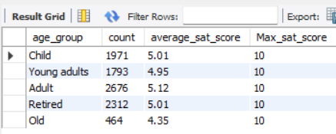

- How many patients have a case manager assigned?
SELECT
CASE
WHEN patient_cm = 0 Then 'No Care Manager'
WHEN patient_cm = 1 THEN 'Has Care Manager'
END AS patient_care_manager,
COUNT(*) AS counts
FROM hospital_er_data_dup
GROUP BY patient_care_manager;
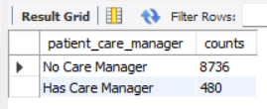

- What is the average wait time for patients with and without case managers?

SELECT
CASE
WHEN patient_cm = 0 Then 'No Care Manager'
WHEN patient_cm = 1 THEN 'Has Care Manager'
END AS patient_care_manager,
COUNT(*) AS counts,
AVG(patient_wait_time) AS AVG_Waittime
FROM hospital_er_data_dup
GROUP BY patient_care_manager;
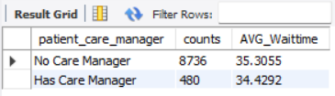

- What is the referral pattern to various departments by case manager involvement?
SELECT
CASE
WHEN patient_cm = 0 Then 'No Care Manager'
WHEN patient_cm = 1 THEN 'Has Care Manager'
END AS patient_care_manager,
Department_referral,
COUNT(*) AS counts,
AVG(patient_wait_time) AS AVG_Waittime
FROM hospital_er_data_dup
GROUP BY patient_care_manager, Department_referral
ORDER BY patient_care_manager ASC;
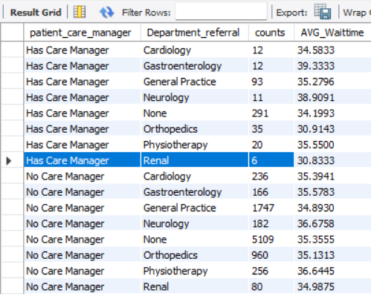
- Patient Admission Counts by Care Manager Assignment
SELECT
CASE
WHEN patient_cm = 0 Then 'No Care Manager'
WHEN patient_cm = 1 THEN 'Has Care Manager'
END AS patient_care_manager,
Patient_admission_flag,
COUNT(*) AS counts
FROM hospital_er_data_dup
GROUP BY patient_care_manager, Patient_admission_flag;
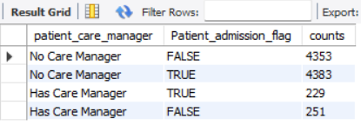

- How do patients with case managers rate their satisfaction versus those without?
SELECT CASE
WHEN patient_cm = 0 THEN 'No Care Manager'
WHEN patient_cm = 1 THEN 'Has Care Manager'
END AS patient_care_manager,
AVG(satisfaction_score),
(AVG(satisfaction_score) / (SELECT AVG(satisfaction_score) FROM hospital_er_data_dup))*100 AS percentage
FROM hospital_er_data_dup
GROUP BY patient_care_manager;
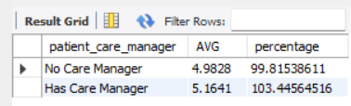

Time-Related Trends
- What are the peak hours/days for ER visits?
SELECT DATE_FORMAT(admission_date, '%a') AS admit_day, COUNT(*) AS counts
FROM hospital_er_data_dup
GROUP BY admit_day
ORDER BY CASE
WHEN admit_day = 'Mon' THEN 1
WHEN admit_day = 'Tue' THEN 2
WHEN admit_day = 'Wed' THEN 3
WHEN admit_day = 'Thu' THEN 4
WHEN admit_day = 'Fri' THEN 5
WHEN admit_day = 'Sat' THEN 6
WHEN admit_day = 'SUN' THEN 7 END;
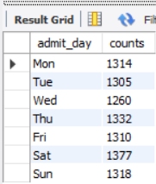

What are the peak hours for ER visits?

SELECT DATE_FORMAT(admission_date, '%H') AS admit_hour, COUNT(*) AS counts
FROM hospital_er_data_dup
GROUP BY admit_hour
ORDER BY admit_hour;

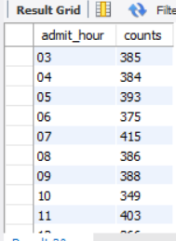

- Is there any correlation between time of day and patient wait time or satisfaction?
SELECT EXTRACT(HOUR FROM admission_date) AS ad_hour,
AVG(patient_wait_time),
AVG(satisfaction_score)
FROM hospital_er_data_dup
GROUP BY ad_hour
ORDER BY ad_hour;
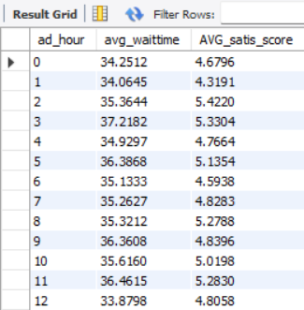

- How do wait times and satisfaction scores change across different seasons or months?

WITH cte_month_avg_waittime_satscore AS
(
SELECT monthname,
MONTH (admission_date) as month_no,
CAST ( AVG( patient_wait_time ) AS decimal (7,2) ) as Average_wait_time,
COUNT (satisfaction_score) AS satis_score_counts,
CAST ( AVG(satisfaction_score) AS decimal(7,2) ) as Average_sat_score
FROM hospital_er_data_dup
GROUP BY monthname, month_no
ORDER BY month_no
)
SELECT monthname,
Average_wait_time,
Average_sat_score
FROM cte_month_avg_waittime_satscore;
